Easy

1

1)

3) 

4) 

5)





6)

Rename file0 file3



8) 

10) “You Found The Flag”

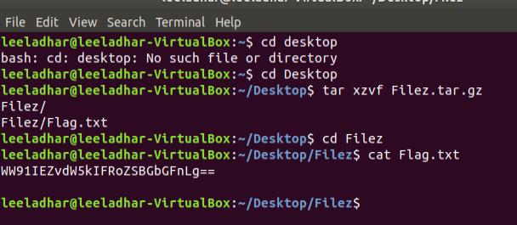

12)

13)

